Tree nursery layout
The layout of the tree nursery includes a shade house, covered pot beds, a tool shed, a compost bin, a rain catchment system, and stools.
Shade House
The shade house is based on the Mittleider design, which is adapted to the Caribbean heat because of its double gable roof that provides adequate ventilation. Notably, this type of shade house/greenhouse is used in Cockpit Country and throughout Guyana.
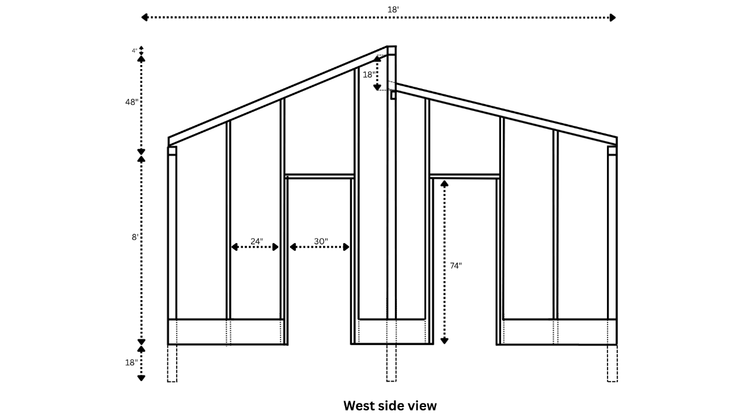
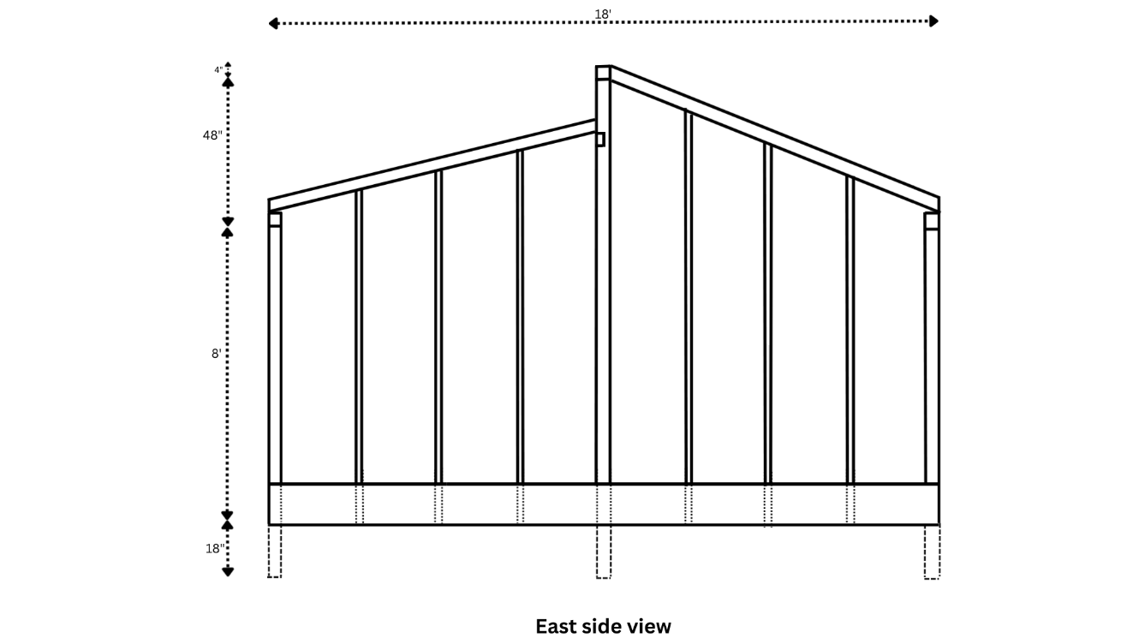
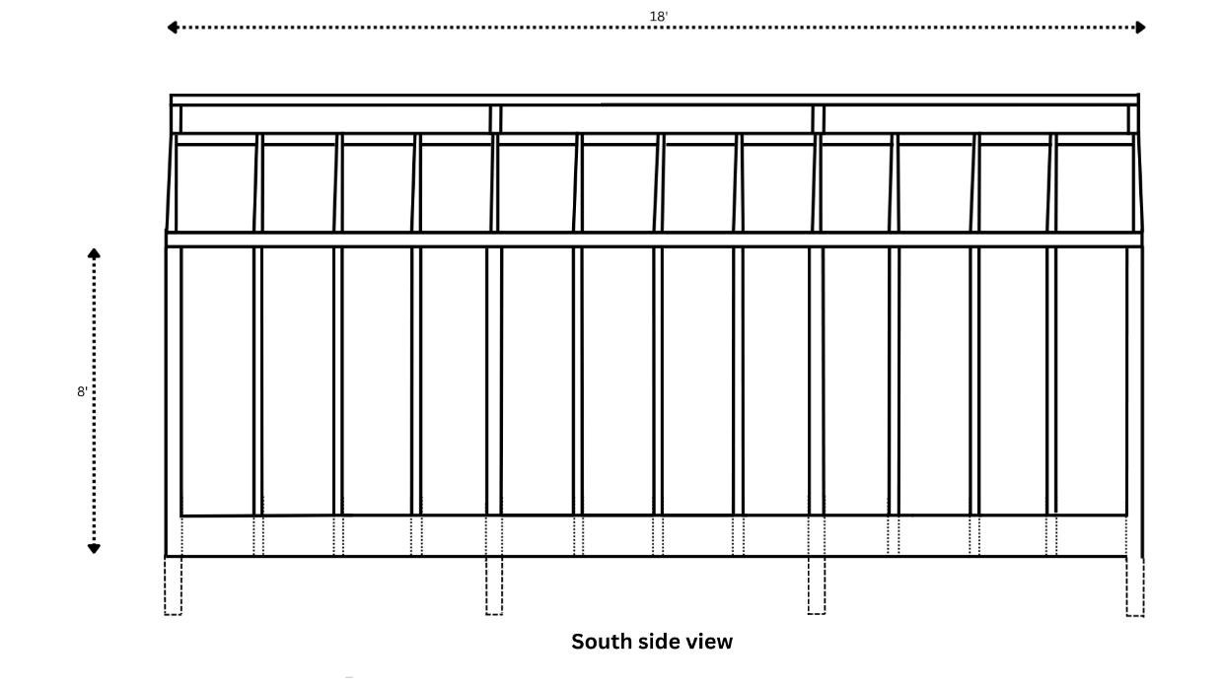
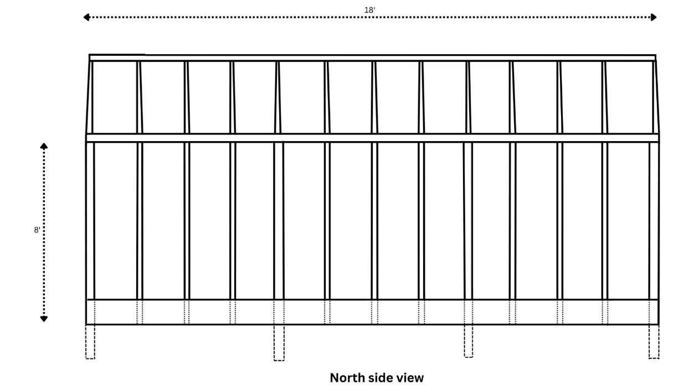

The 18x24 shade house can accommodate 16 students. A 30” table runs the length of the inner walls. A larger, 5x13 middle table is fixed to each side of the central posts. The passageway between the tables is 44” wide, and five square feet clear the doorways. A simple ventilation system is controlled by pulleys, ropes and hooks. The shade house has a plastic covering on top of shade cover, with roll-way flaps and retractable roof shading.
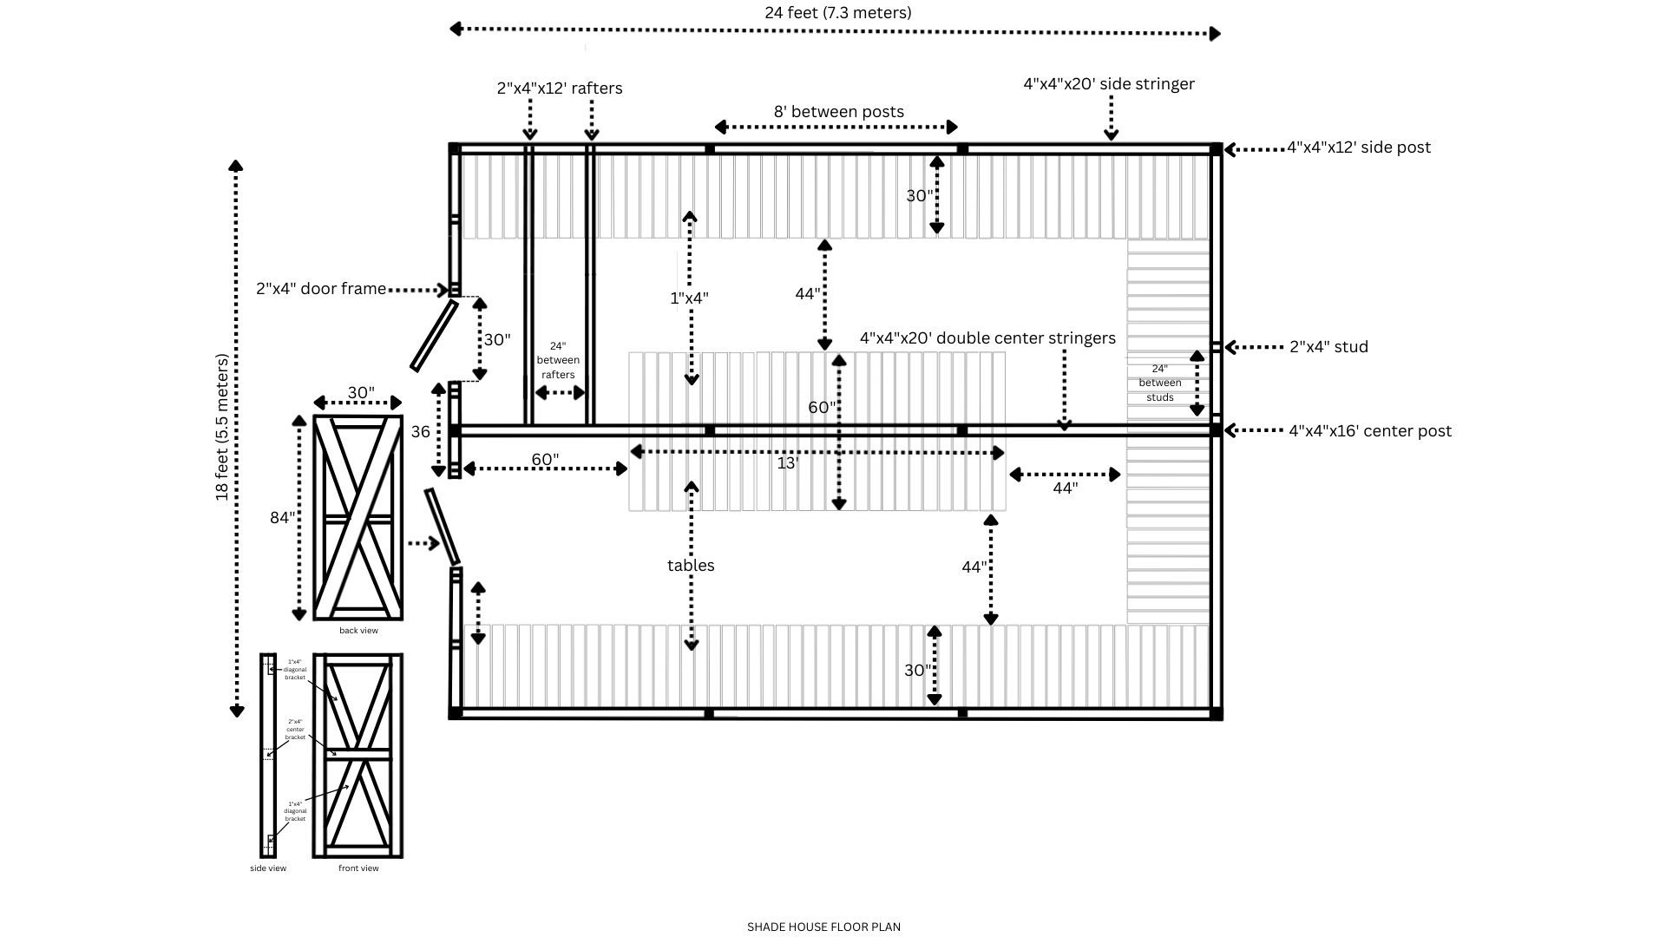
Covered beds
Polythene covered beds are used to harden off seedlings and to root cuttings. Plastic covering preserves a high atmospheric humidity and help keep the air temperature constant. Plants are protected from rain and wind damage and kept cool and moist. Non-mist poly-propagators are covered beds that are cheap and simple to build. Together, the two 4x8 covered beds of the tree nursery can hold approximately 500 potted seedlings.
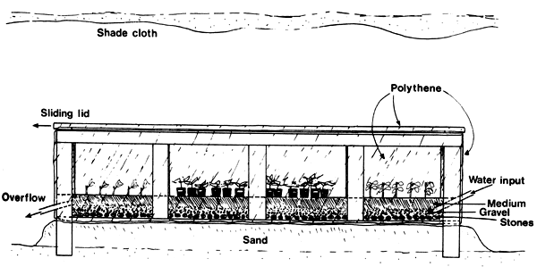

Illustration of a typical non-mist poly-propagator

Tool shed
The tool shed is a 4x6 lean-to that can be placed against the canteen wall. Its detailed building instructions are available online.

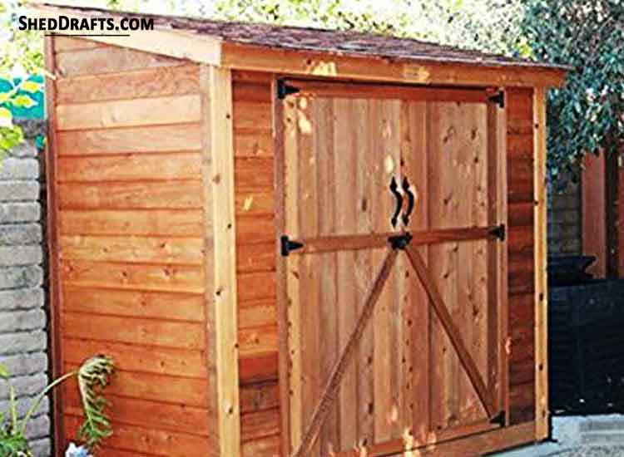

Photo of a 4x6 lean-to tool shed

Compost bins
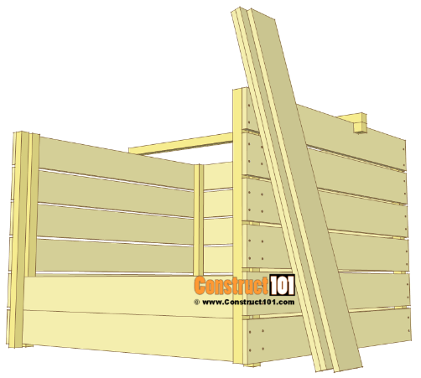
Two compost bins will receive all the organic matter produced by the canteen. They will be situated between the garden beds on the side of the canteen building. Detailed plans for a 4x4 compost bin found online will be adjusted to a 40”x40” dimension.

Illustration of a 4x4 compost bin

Rain catchment system
The simple rain catchment system is composed of a 400-gallon water tank along with a rain gutter running the 53’4” length of the school building’s back wall, with a pipe connecting the downspout to the water tank.

Stools
Along with the tool shed and compost bin, detailed plans for the construction of the stools are available online. Sixteen stools are needed in all. By building them last, leftover wood pieces from the other structures can be salvaged, and volunteers can get creative.
